Analyzing the Impact of Car

Features on Price and Profitability

Analysing the Impact of Car Features on Price and Profitability

**Project description**

The automotive industry has been rapidly evolving over the past few decades, with a growing focus on fuel efficiency, environmental sustainability, and technological innovation. With increasing competition among manufacturers and a changing consumer landscape, it has become more important than ever to understand the factors that drive consumer demand forecasts problem could be approached by analysing the relationship between a car's features, market category, and pricing, and identifying which features and categories are most popular among consumers and most profitable for the manufacturer. By using data analysis techniques such as regression analysis and market segmentation, the manufacturer could develop a pricing strategy that balances consumer demand with profitability and identify which product features to focus on in future product development efforts. This could help the manufacturer improve its competitiveness in the market and increase its profitability over time

**Project Problem:**

Investigating the relationship between a car's features and its popularity: By examining the popularity variable in the dataset, a data analyst could identify which features are most popular among consumers and how they affect a car's popularity. This could help manufacturers make informed decisions about product development and marketing. Predicting the price of a car based on its features and market category: By using the various features and market category variables in the dataset, a data analyst could develop a model to predict the price of a car. This could help manufacturers and consumers understand how different features affect the price of a car and make informed decisions about pricing and purchasing.

Overall, this dataset could be a valuable resource for data analysts interested in exploring

various aspects of the automotive industry and could provide insights that could inform

decisions related to product development, marketing, and pricing.

Overall, this dataset might be a significant resource for data analysts interested in researching numerous facets of the automobile business, as well as give insights that could drive product development, marketing, and price decisions.

I used the provided automobile data set. First, I grasp the data, and then I clean it up. I eliminated blank cell rows and duplicated rows to tidy up the data.

**Approach:**

I used MS-Excel for analytics purposes to execute various functions such as pivot tables, graphs, chart regression, and so on. Because it is simple to use and may provide an eye-catching dashboard.

Tech-Stack Used:

1. Ms excel and ms word

Tech-Stack Used:

1. Ms Excel
2. Ms. Word
3. Python

**Tasks: Analysis**

Before diving into the analysis of the given dataset, it is important to perform thorough data cleaning to ensure accurate and reliable results. You need to build an interactive dashboard in Excel from the tasks given below:

**Insight Required:** How does the popularity of a car model vary across different market categories?

● **Task 1.A:** Create a pivot table that shows the number of car models in each market category and their corresponding popularity scores.

Inference: Pivot table has been created that shows the number of car models in each market category and their corresponding popularity score.

● **Task 1.B**: Create a combo chart that visualizes the relationship between market category and popularity

**Inference:**

From below line chart we can see in market category Hatchback and Fuel Flex are the highest populated and having highest number of cars.

Insight Required: What is the relationship between a car's engine power and its price?

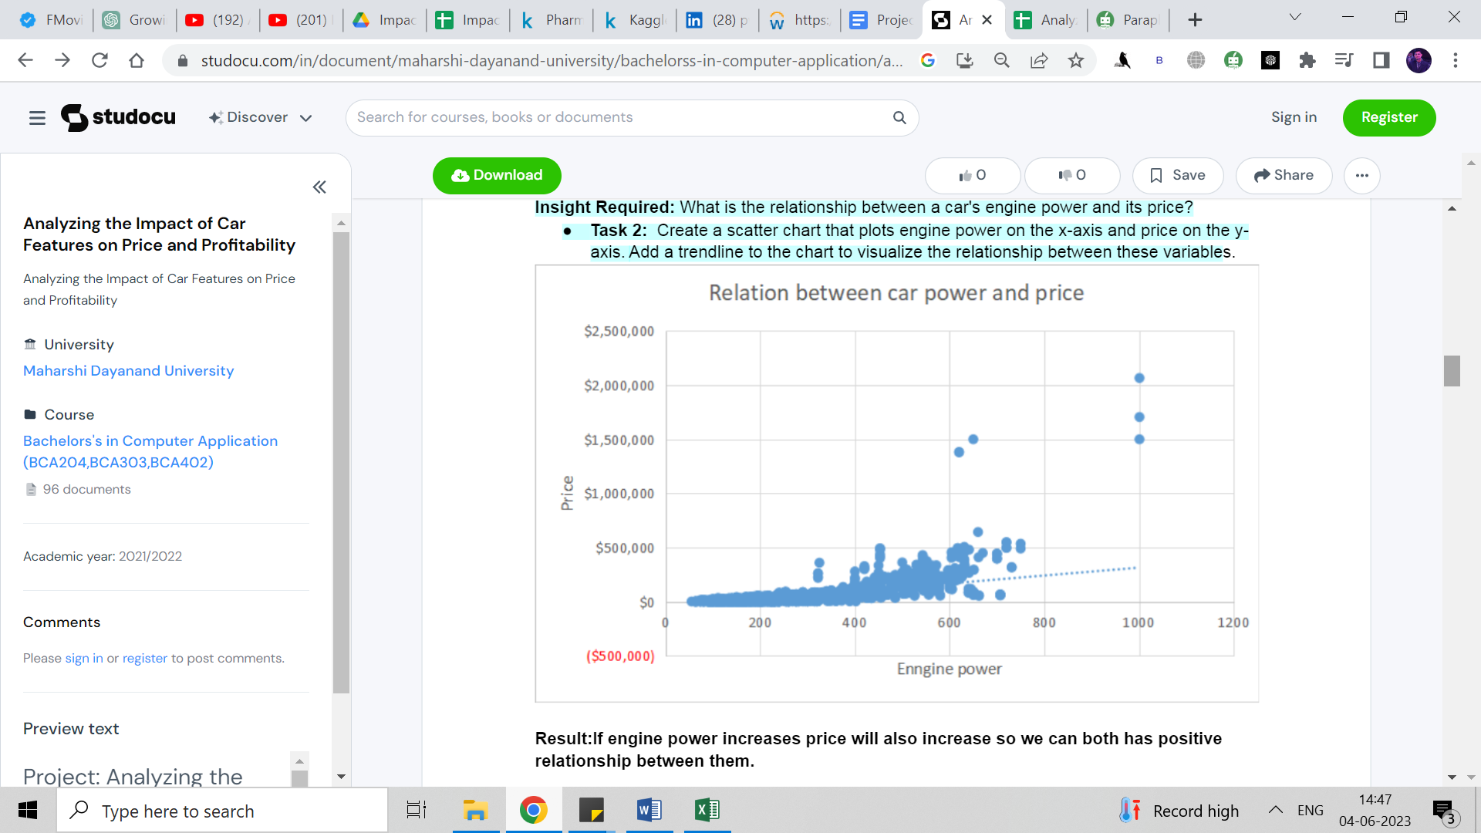● **Task 2:** Create a scatter chart that plots engine power on the x-axis and price on the y-axis. Add a trendline to the chart to visualize the relationship between these variable

**Inference:**

From above Scatter plot we can see cars which have high engine power having higher price. Thus, car's power increase car's price will also increase.

Insight Required: Which car features are most important in determining a car's price?

**Task 3:** Use regression analysis to identify the variables that have the strongest relationship with a car's price. Then create a bar chart that shows the coefficient values for each variable to visualize their relative importance.

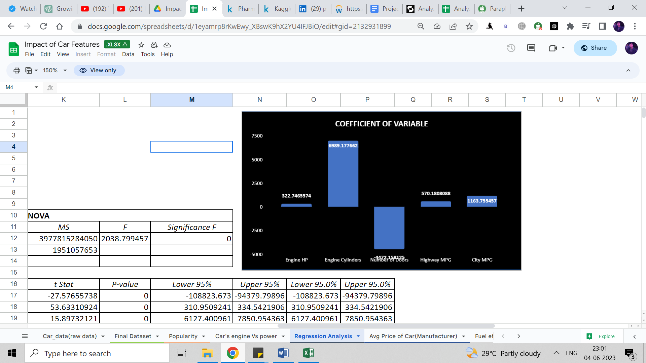

**Inference:**

From above Bar chart we can see Engine Cylinders having the strongest relationship with the MSRP.

Insight Required: How does the average price of a car vary across different manufacturers?

● **Task 4.A:** Create a pivot table that shows the average price of cars for each manufacturer.

● **Task 4.B:** Create a bar chart or a horizontal stacked bar chart that visualizes the relationship between manufacturer and average price.

Inference:

From above Bar chart we can see Car brand Bugatti and Lamborghini having the highest average price.

Insight Required: What is the relationship between fuel efficiency and the number of cylinders in a car's engine?

**Task 5.A:** Create a scatter plot with the number of cylinders on the x-axis and highway MPG on the y-axis. Then create a trendline on the scatter plot to visually estimate the slope of the relationship and assess its significance.

**Task 5.B:** Calculate the correlation coefficient between the number of cylinders and highway MPG to quantify the strength and direction of the relationship.

|  |  |
| --- | --- |
| **Correlation Coefficient, r=** | **-0.62031** |

Inference:

From above scatter plot we can see that no. of cylinders having 4 is giving maximum fuel efficiency.

Fuel efficiency is inversely proportional to no. of cylinders, higher the no. of cylinder lowers the fuel efficiency.

**Correlation Coefficient, r** between the number of cylinders and highway MPG to quantify the strength and direction of the relationship is found to be -**0.62031.**

Building the Dashboard:

Now for the Next portion of the Project, you need to create the Interactive Dashboard.

Use filters and slicers to make the chart interactive. The client has requested these questions

given below:

Task 1: How does the distribution of car prices vary by brand and body style?

●Hints: Stacked column chart to show the distribution of car prices by brand and body

style. Use filters and slicers to make the chart interactive. Calculate the total MSRP for

each brand and body style using SUMIF or Pivot Tables.

Result: Chevrolet has the highest price distribution

**Building the Dashboard:**

Now for the Next portion of the Project, you need to create the Interactive Dashboard. Use filters and slicers to make the chart interactive. The client has requested these questions given below:

**Task 1:** How does the distribution of car prices vary by brand and body style?

● Hints: Stacked column chart to show the distribution of car prices by brand and body style. Use filters and slicers to make the chart interactive. Calculate the total MSRP for each brand and body style using SUMIF or Pivot Tables.

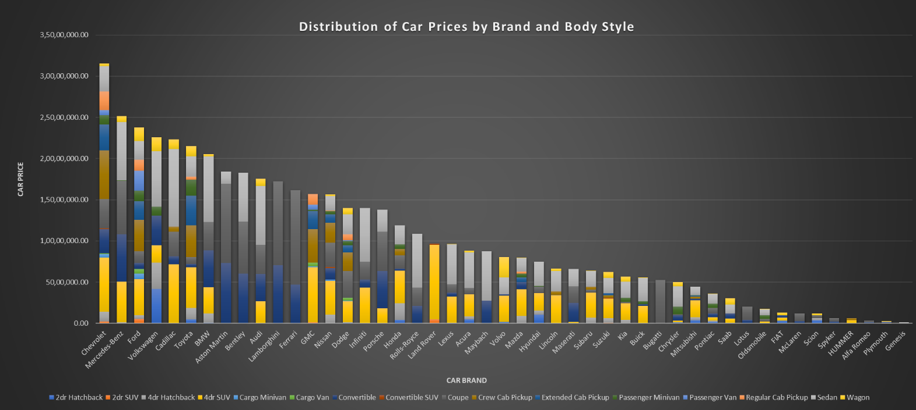

Inference: From above Stacked column chart we can see the body style of Chevrolet and Mercedes Benz having highest contribution in car's price.

**Task 2:** Which car brands have the highest and lowest average MSRPs, and how does this vary by body style?

**Hints:** Clustered column chart to compare the average MSRPs across different car brands and body styles. Calculate the average MSRP for each brand and body style using AVERAGEIF or Pivot Tables.

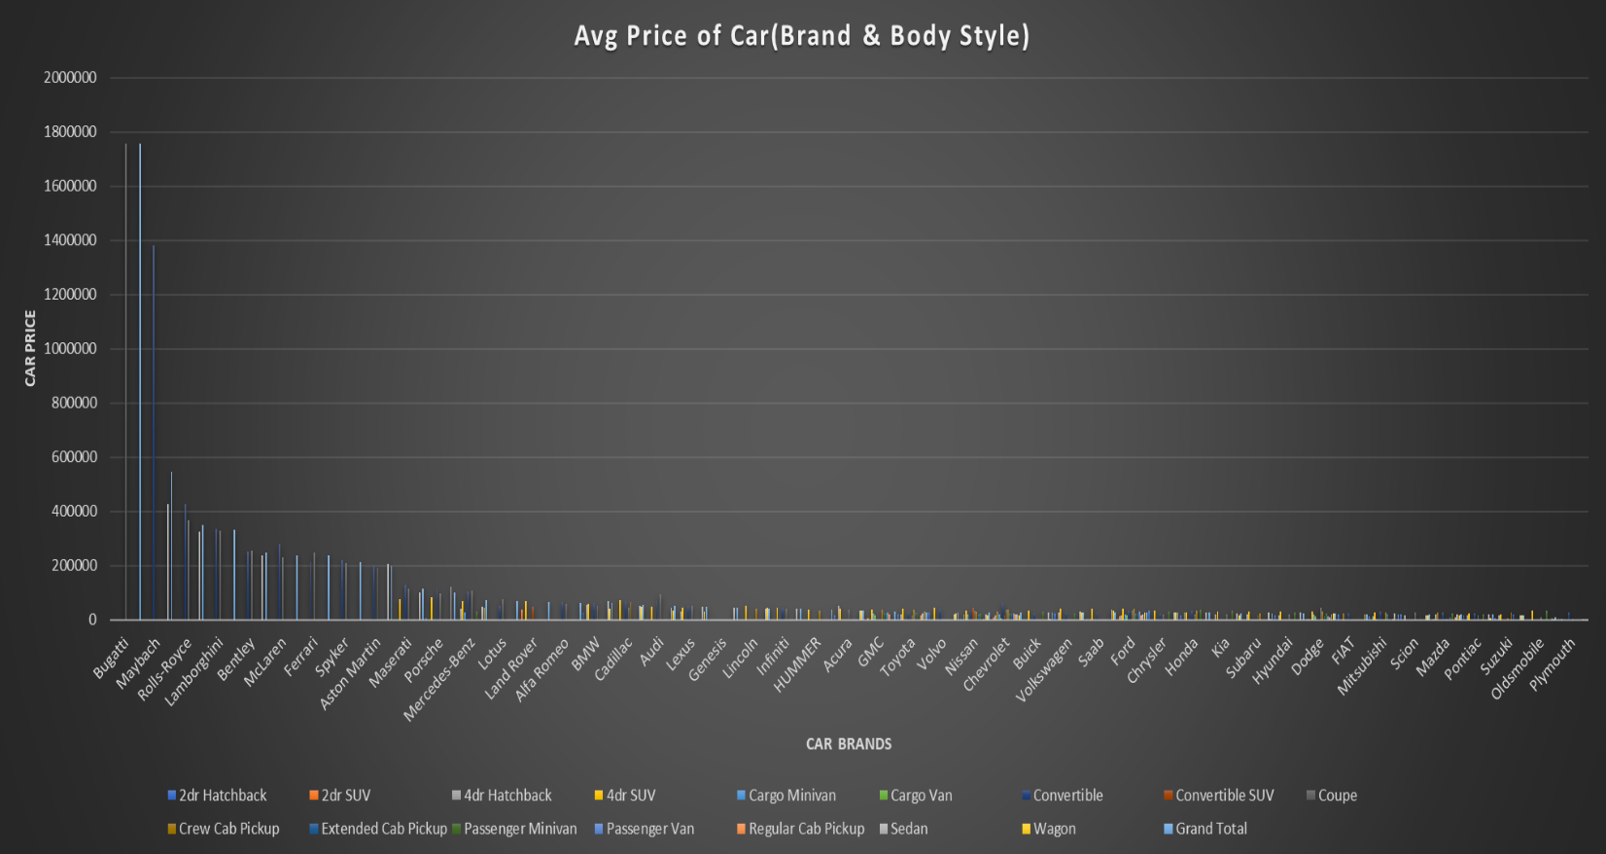

**Inference:**

From above Clustered column chart we can see Coupe style of Bugatti and Convertible style of Maybach having highest no. of average car's price and Plymouth has the lowest Average MSRP.

**Task 3:** How do the different feature such as transmission type affect the MSRP, and how does this vary by body style?

**Hints:** Scatter plot chart to visualize the relationship between MSRP and transmission type, with different symbols for each body style. Calculate the average MSRP for each combination of transmission type and body style using AVERAGEIFS or Pivot Tables.

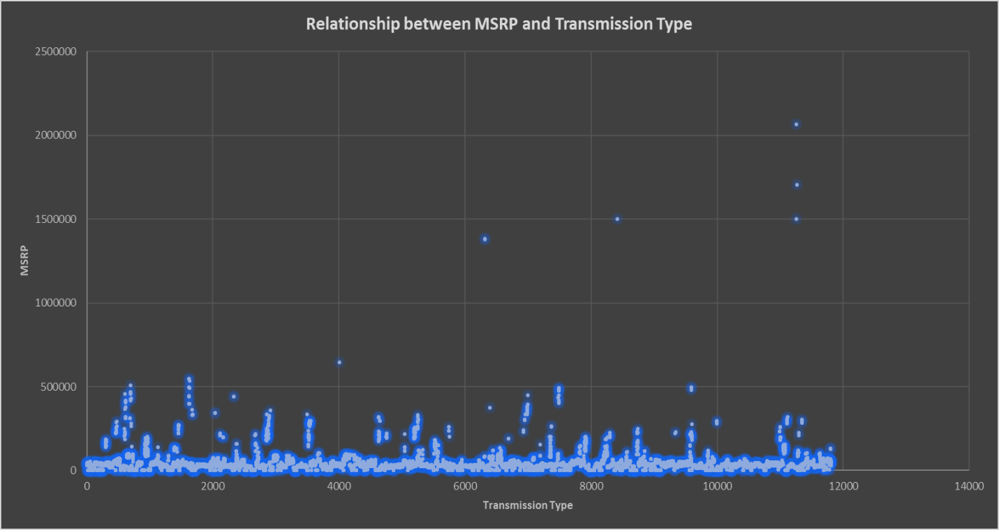

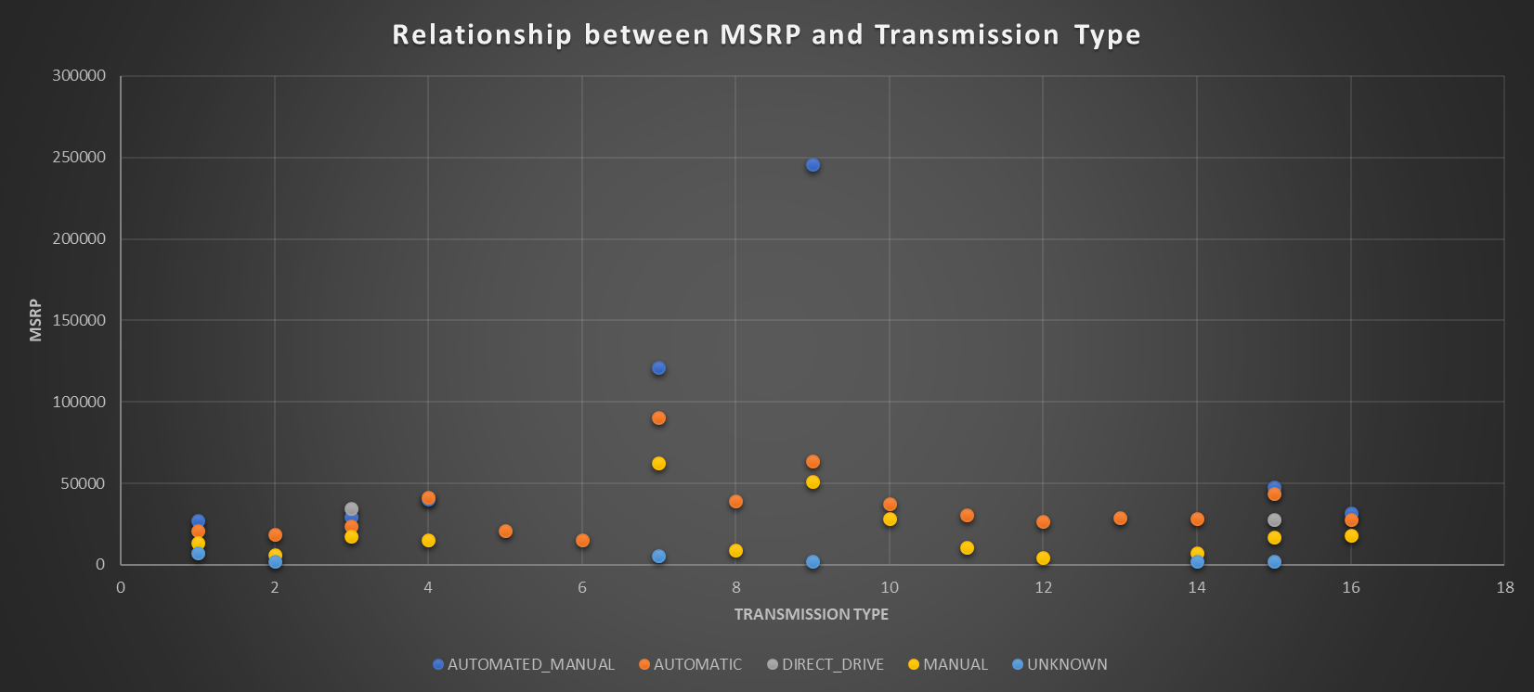

**Inference:**

From above scatter plot we see the automated convertible and automated_manual coupe is highly contributing in MSRP.

**Task 4:** How does the fuel efficiency of cars vary across different body styles and model years?

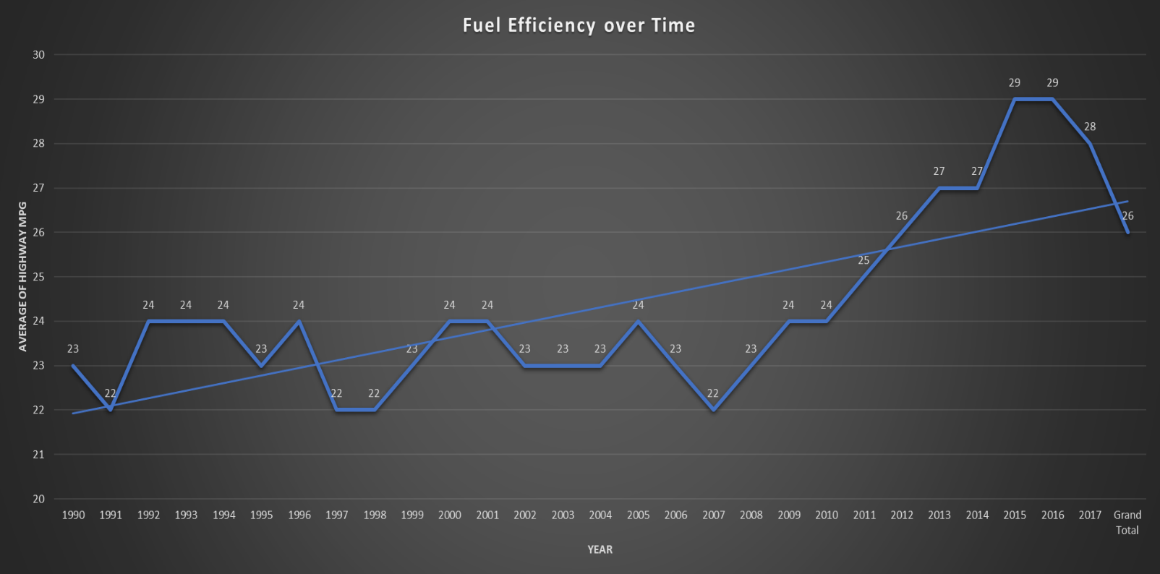**Hints:** Line chart to show the trend of fuel efficiency (MPG) over time for each body style. Calculate the average MPG for each combination of body style and model year using AVERAGEIFS or Pivot Tables.

Inference:

From below Line chart we can see as time increased fuel efficiency (Highway MPG) also increased or improved.

**Task 5:** How does the car's horsepower, MPG, and price vary across different Brands?

**Hints:** Bubble chart to visualize the relationship between horsepower, MPG, and price across different car brands. Assign different colours to each brand and label the bubbles with the car model name. Calculate the average horsepower, MPG, and MSRP for each car brand using AVERAGEIFS or Pivot Tables.

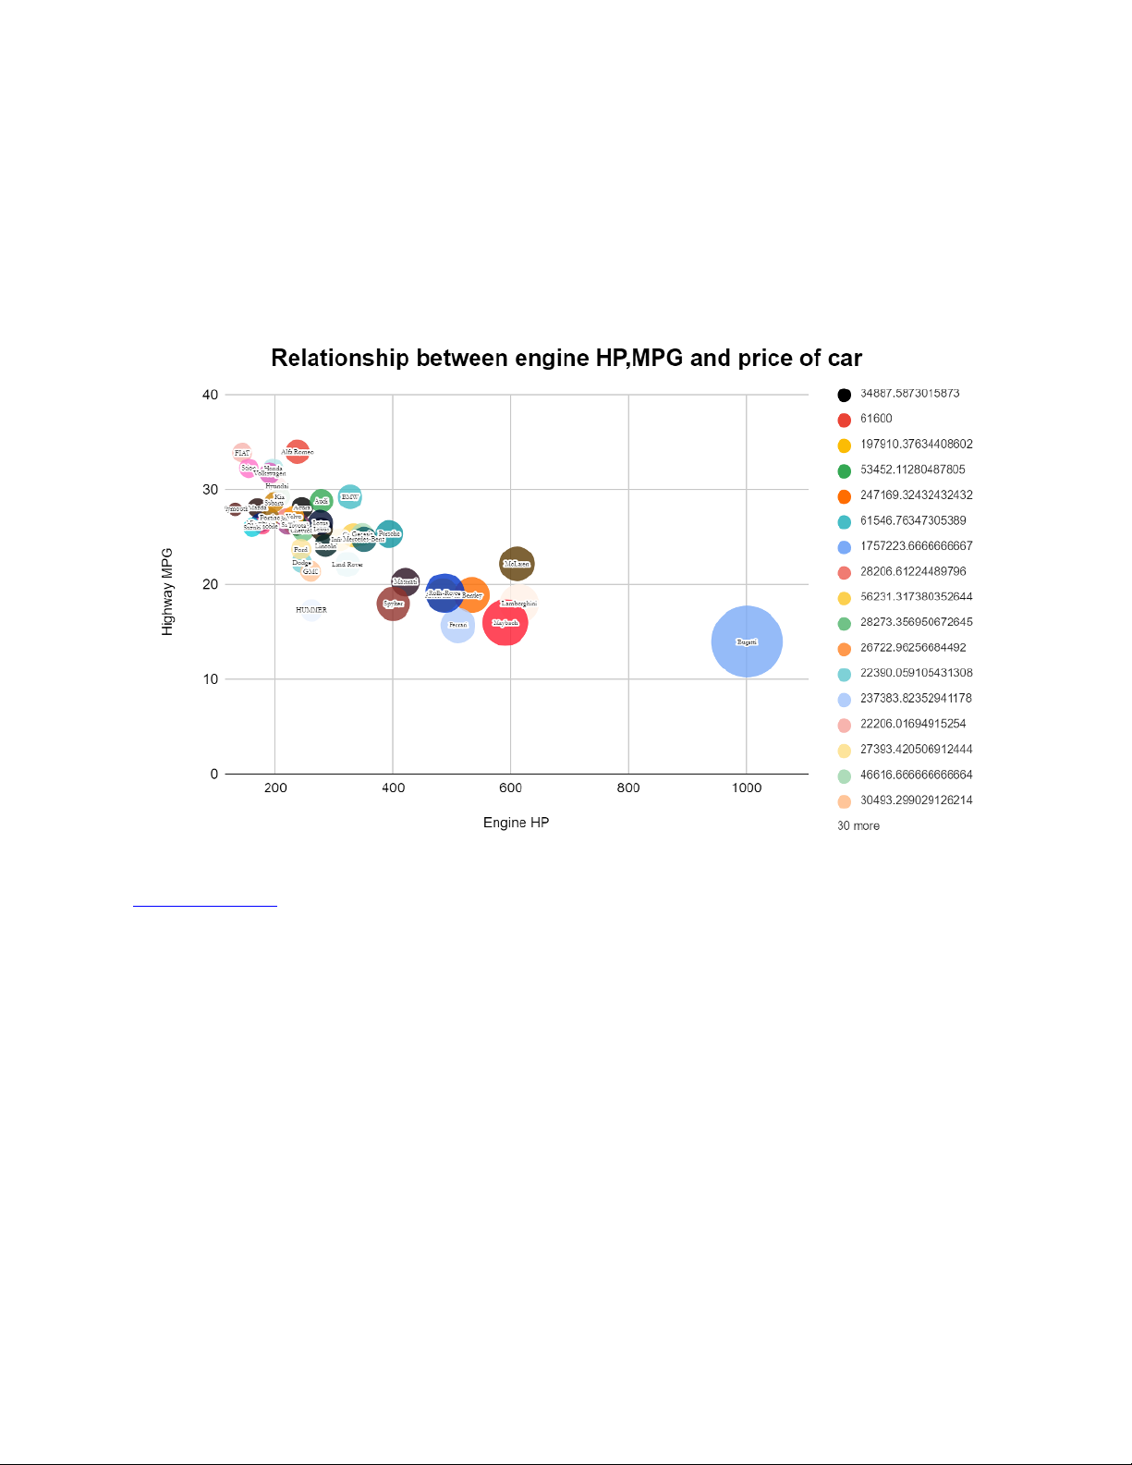**Inference:**

From below Bubble chart we can see the car which have high engine hp their price are also getting high and cars which have high highway MPG their price getting low. Thus, higher the engine power higher the price.

**Conclusion**

* Coupe body style is contributing maximum in car’s MSRP.
* In transmission type automated_manual creating high impact because in a single car having both automated and manual gear system will be more beneficial rather than single gear system.
* Overall, fuel efficiency and Coupe body style features are highly impacting the car price and profitability.

**Result:**

After running all the formulas in Microsoft Excel and plotting the charts we analysed all the data sets of this Project.

In the making of this report, we used our Microsoft Excel knowledge and Python as a real-world example.

**Drive Link**

Link for the drive containing the excel file and other reports.

[**https://drive.google.com/drive/folders/1AEyH15TiLdKp0JzW5UXY6-dowcBpOuEx?usp=sharing**](https://drive.google.com/drive/folders/1AEyH15TiLdKp0JzW5UXY6-dowcBpOuEx?usp=sharing)